**Awaiting Ticket Resolution**

Conditions:

Example: 157512824

***Step 1*** : Check if the task Awaiting Ticket Resolution is in Ready State using the below query:

**Inconcert SqL Query:** -

Select ord.purge_IND,ms.ms_task_id,ord.usrp_order_number,sub.order_gate1_status, sub.ms_sub_order_id,sub.wan_link_ip_addr, wf.name, wf.status, wf.job_id, wf.task_id, wf.first_ready_time,wf.ready_time, wf.due_date, wf.done_time, wf.first_ready_time,wf.skipped_time, wf.perform_condition, wf.ITERATE_CONDITION

from ms_order ord, ms_sub_order sub,ms_job j,wf_task wf,wf_job job,ms_task ms

where

Ord.Usrp_Order_Number In

('157968653')and ord.ms_order_id = sub.ms_order_id and ms_sub_order_id = j.entity_id

and wf.job_id= hextoraw(j.wf_job_id) And Wf.Job_Id = Job.Job_Id and wf.task_id= ms.WF_TASK_ID

and j.entity_type=5 and (wf.status in (1));

**mS Updates SQL Query:-**

SELECT usrp_order_number, o.ms_order_id, ms_sub_order_id, t.name, t.status_updated_date , t.status, t.* FROM ms_task t, ms_job j, ms_order o , ms_sub_order so WHERE usrp_order_number IN (‘157968653’) AND so.ms_order_id = o.ms_order_id AND entity_id = ms_sub_order_id AND entity_type = 5 AND t.wf_job_id = j.wf_job_id and t.status = 1;

**With Error Task:-**

**Task “Receive SXP CSR Result/Trigger SXP for CSR” is in waiting state**:

Let’s take a tour with live Order example:

Example: 147075686

*Step 1*: Awaiting Ticket Resolution is Ready State



*Step 2*: Receive SXP CSR Result/Trigger SXP for CSR is in Waiting State



**EFMS GUI** [**URL :-**](URL:-)

[**http://efmsms.it.att.com:8008/MS**](http://efmsms.it.att.com:8008/MS)

**EFMS GUI:**

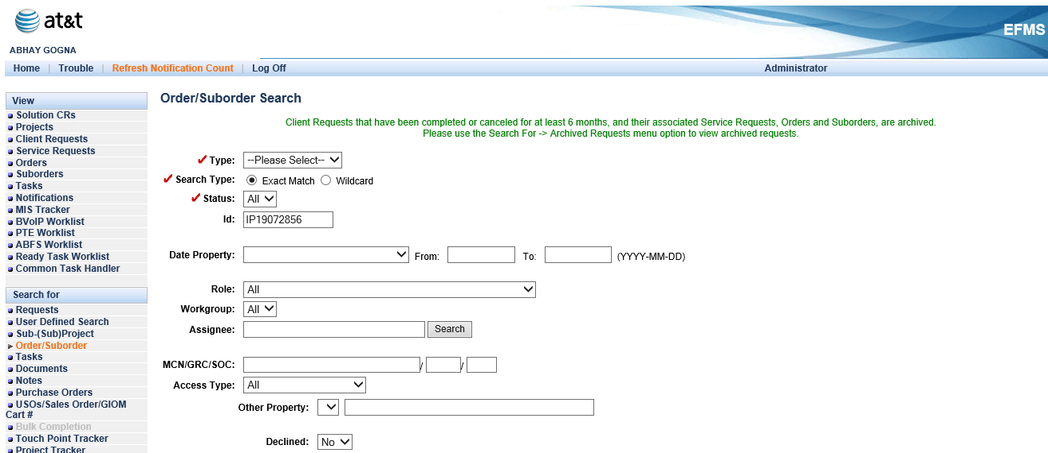

**Order / Sub-Order Level:**

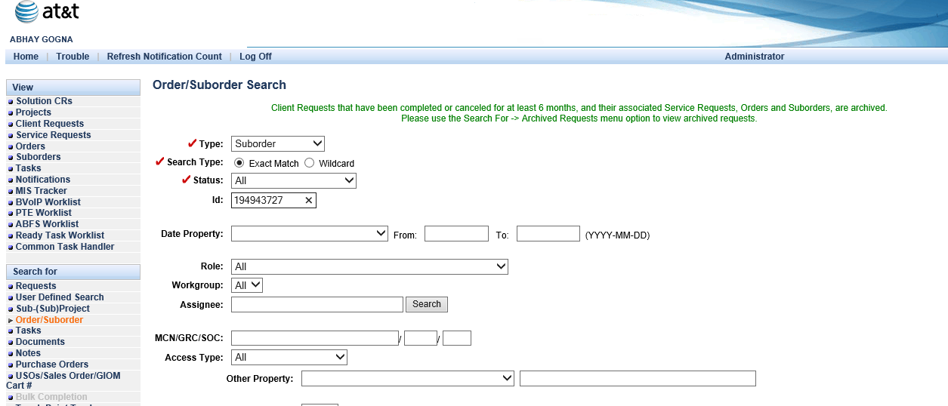

*Step 3*: Get the AOTS Ticket Number from GUI, under Suborder tasks, Hit open to Awaiting Ticket Resolution

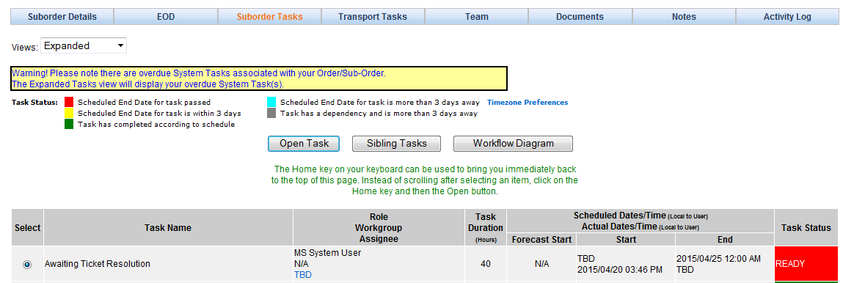

*Step 4:* Get the AOTS Ticket Number:

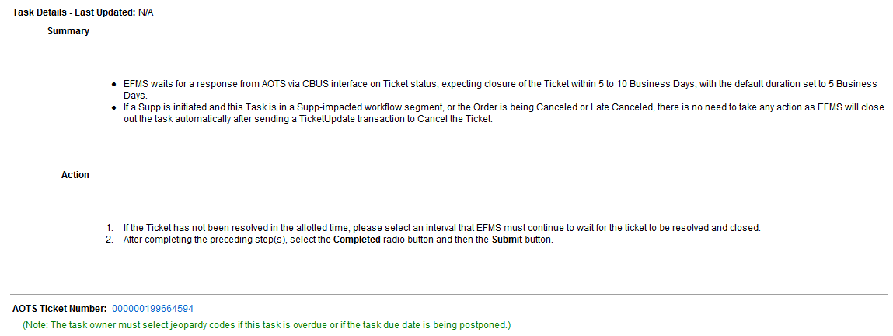

Close the AOTS ticket as auto ticket in *BMC Remedy*.

Workaround: Open the BVoIP order in GUI, click on the task summary get the AOTS auto ticket number and close the auto ticket in BMC Remedy.

**Note**: If none of the above conditions match force complete the Awaiting Ticket Resolution